1. Participant
Closing Date : 13, Aug, 2027
*Please read carefully the exhibition regulations before filling out the application form.

Name of Sign*
(or Company)
Address*
Address* | City |  |  | Country |  |  |  | Zip-Code
Contact No.* | (Country Code) - |  |  |  | FAX |  | (Country Code) -
Website* |  |  |  |  | Email*
Representative*
Person in Charge* |  |  |  |  | Cell phone* |  | (Country Code) -
Title* |  |  |  |  | Department
Exhibition Items* (Please, Check in the box)
Craft work |  |  | □ Metal □ Pottery □ Wood □ Leather □ Crochet □ Fabric □ Glass □ Paper □ Quilting  □ Jewelry □ Boudoir □ Lacquered goods □ Knots □ Dolls □ Flower □ Sugar □ Others
Design & Art |  |  | □ Paintings □ Sculptures □ Objets □ Caligraphy □ Webtoons □ Design □ Stationery  □ Books □ Others
Fashion & Accessories |  |  | □ Clothes □ Traditional costumes □ Fusion traditional costumes □ Bags □ Shoes □ Watches  □ Bracelets □ Necklaces □ Earrings □ Rings □ Keyring □ Accessories □ Others
Beauty |  |  | □ Cosmetic goods □ Soaps □ Aroma goods □ Perfumes □ Diffusers □ Candles □ Others
Interior &  Design Goods |  |  | □ Furniture □ Interior goods □ Tableware □ Healing & Therapies □ Lighting □ Gardening  □ Recycling □ Office goods □ Goods for kids □ Goods for pets □ IT goods □ Gifts  □ Daily items □ Living goods □ Others
Materials & Tools |  |  | □ Materials □ Subsidiary materials □ Tools □ 3D printing □ DIY kit □ Others
Others |  |  | □ Sales of products □ Online markets □ Open markets □ Markets □ Classes □ Others
Singularity of Items

2. Application for Exhibition Space
Booth Type | Unit Price  (USD) | Dimensions  (Meter: W x D x H) | No. of Booth(s) | Sub-Total
Wooden A | USD 1,000 | 2.0m(1.0m) x 2.0m(1.0m) x 2.4m | Booth(s) | USD
Wooden B | USD 1,300 | 2.0m x 2.0m(1.0m) x 2.4m | Booth(s) | USD
Wooden C | USD 1,700 | 3.0m x 2.0m x 2.4m | Booth(s) | USD
Standard Shell A | USD 900 | 2.0m x 2.0m x 2.5m | Booth(s) | USD
Standard Shell B | USD 1,300 | 3.0m x 2.0m x 2.5m | Booth(s) | USD
Workshop | USD 1,700 | 4.0m x 3.0m x 2.5m | Booth(s) | USD
Raw Space | USD 1,200 | 3.0m x 2.0m | Booth(s) | USD
Corner  (Extra Charge) | USD 100 | exposed to 2 hallways | Booth(s) | USD
※ Corner booth price is not included in the unit booth price. (USD 100)
※ All booth types, including corner booths, are available on a first-come, first-served basis and may sell out quickly.
※ Corner booths are assigned with priority given to those who request them, based on the order of application date.
※ Raw Space: Organizer provides only exhibition space, should be applied more than 2-booth.
※ Provided supplies may vary depending on booth type. Please visit our website for more information. (knittingfair.com)
※ Application for workshop booth will be limited to one team per item on a first-come, first-served basis. (Contact : +82-2-761-2528, 2587)
※ The booth information above is subject to change depending on the circumstances of host and detailed information will be provided at the timing of application for booth.

※ Design of Booth
Wooden A | Wooden B | Wooden C
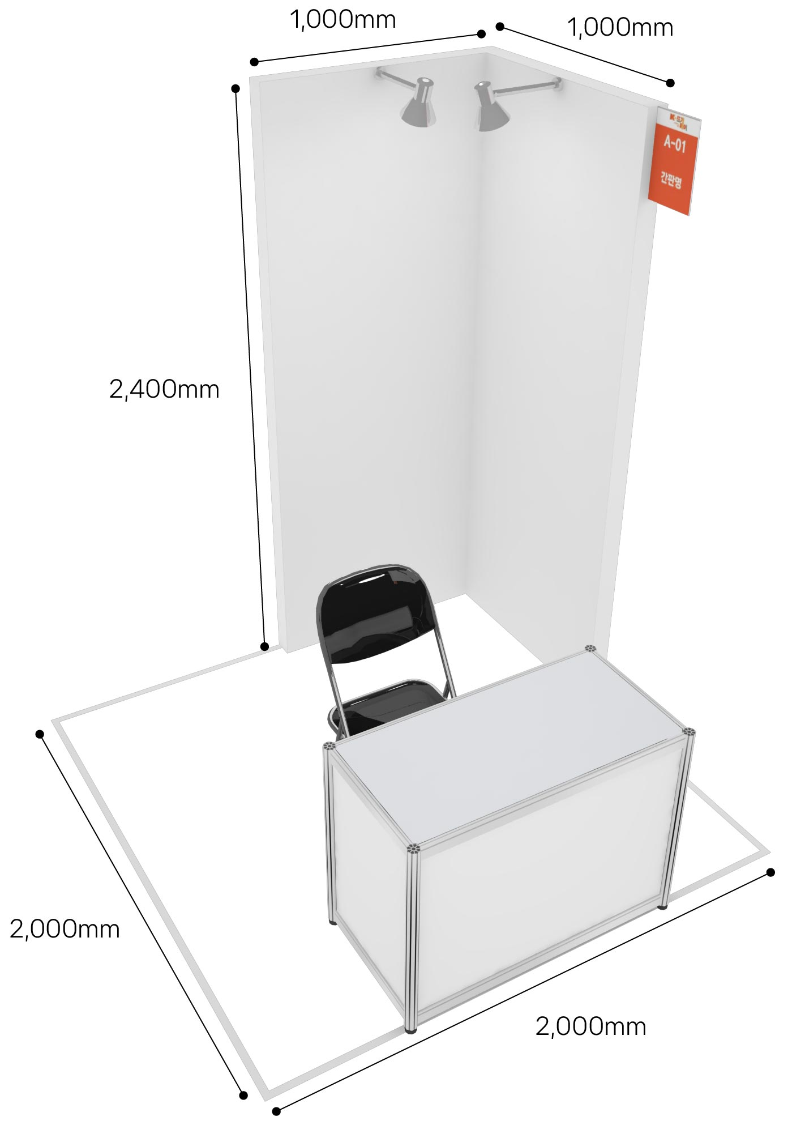 | 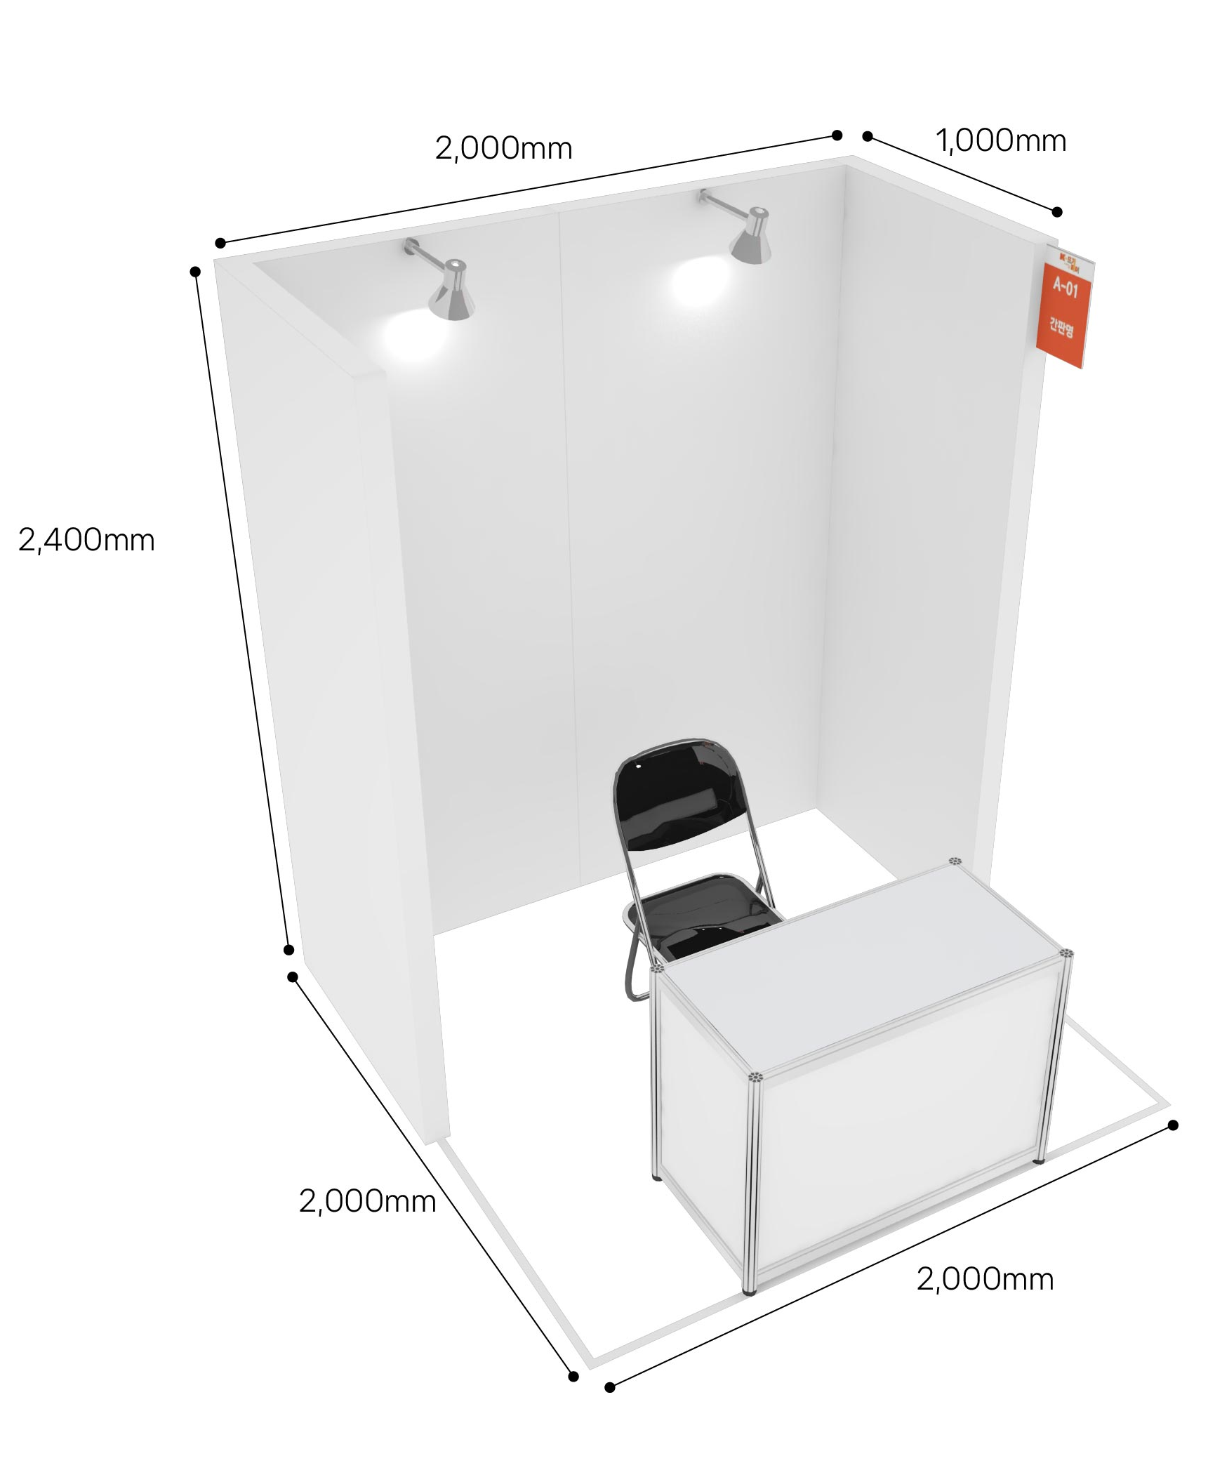 | 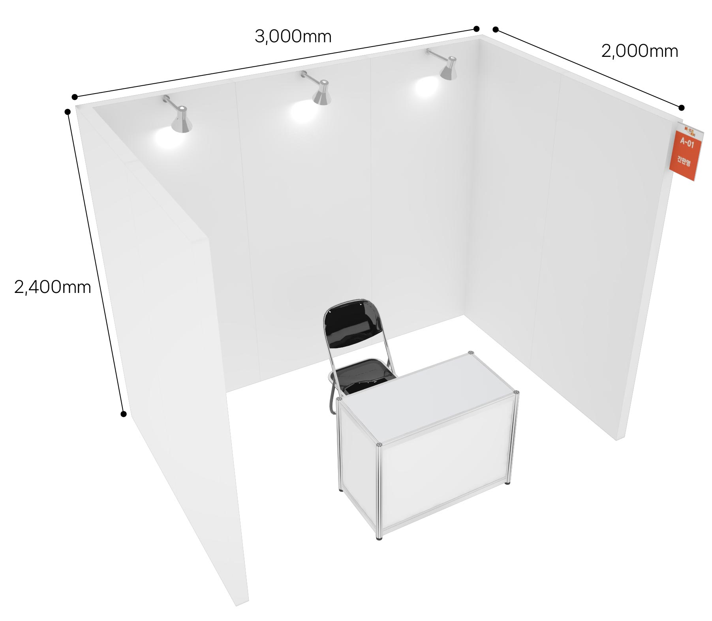
Standard Shell A | Standard Shell B | Workshop
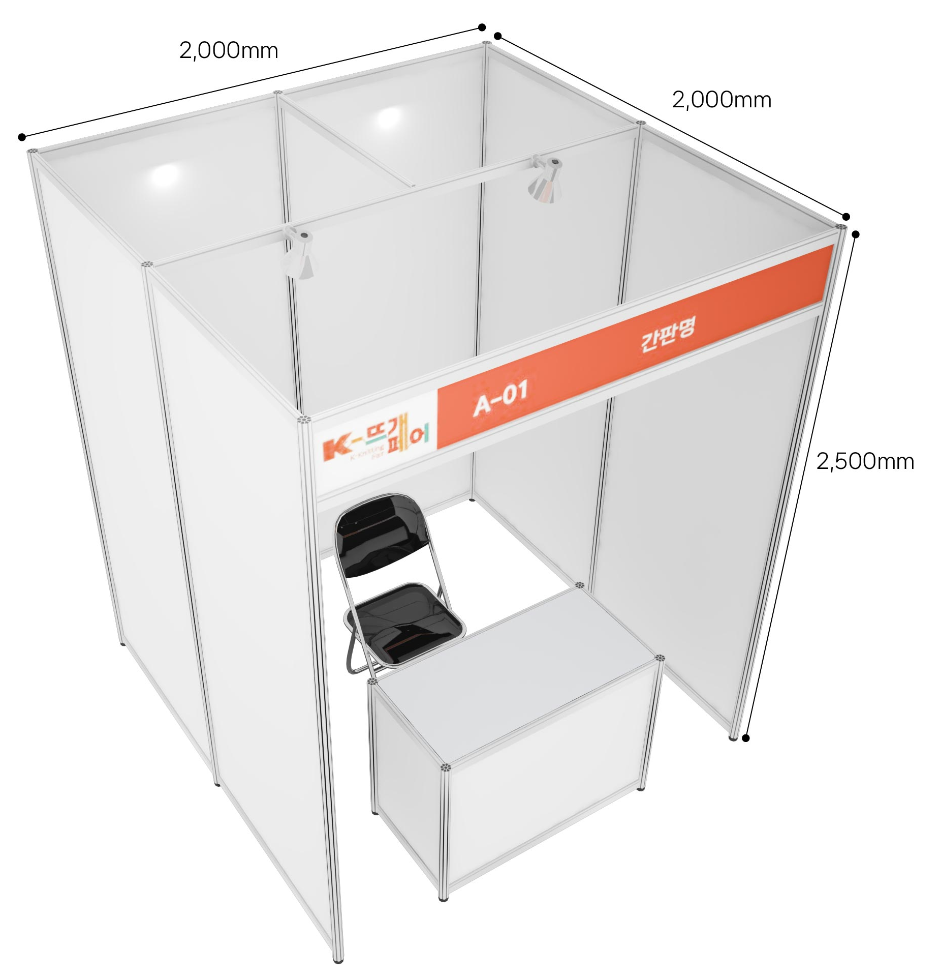 | 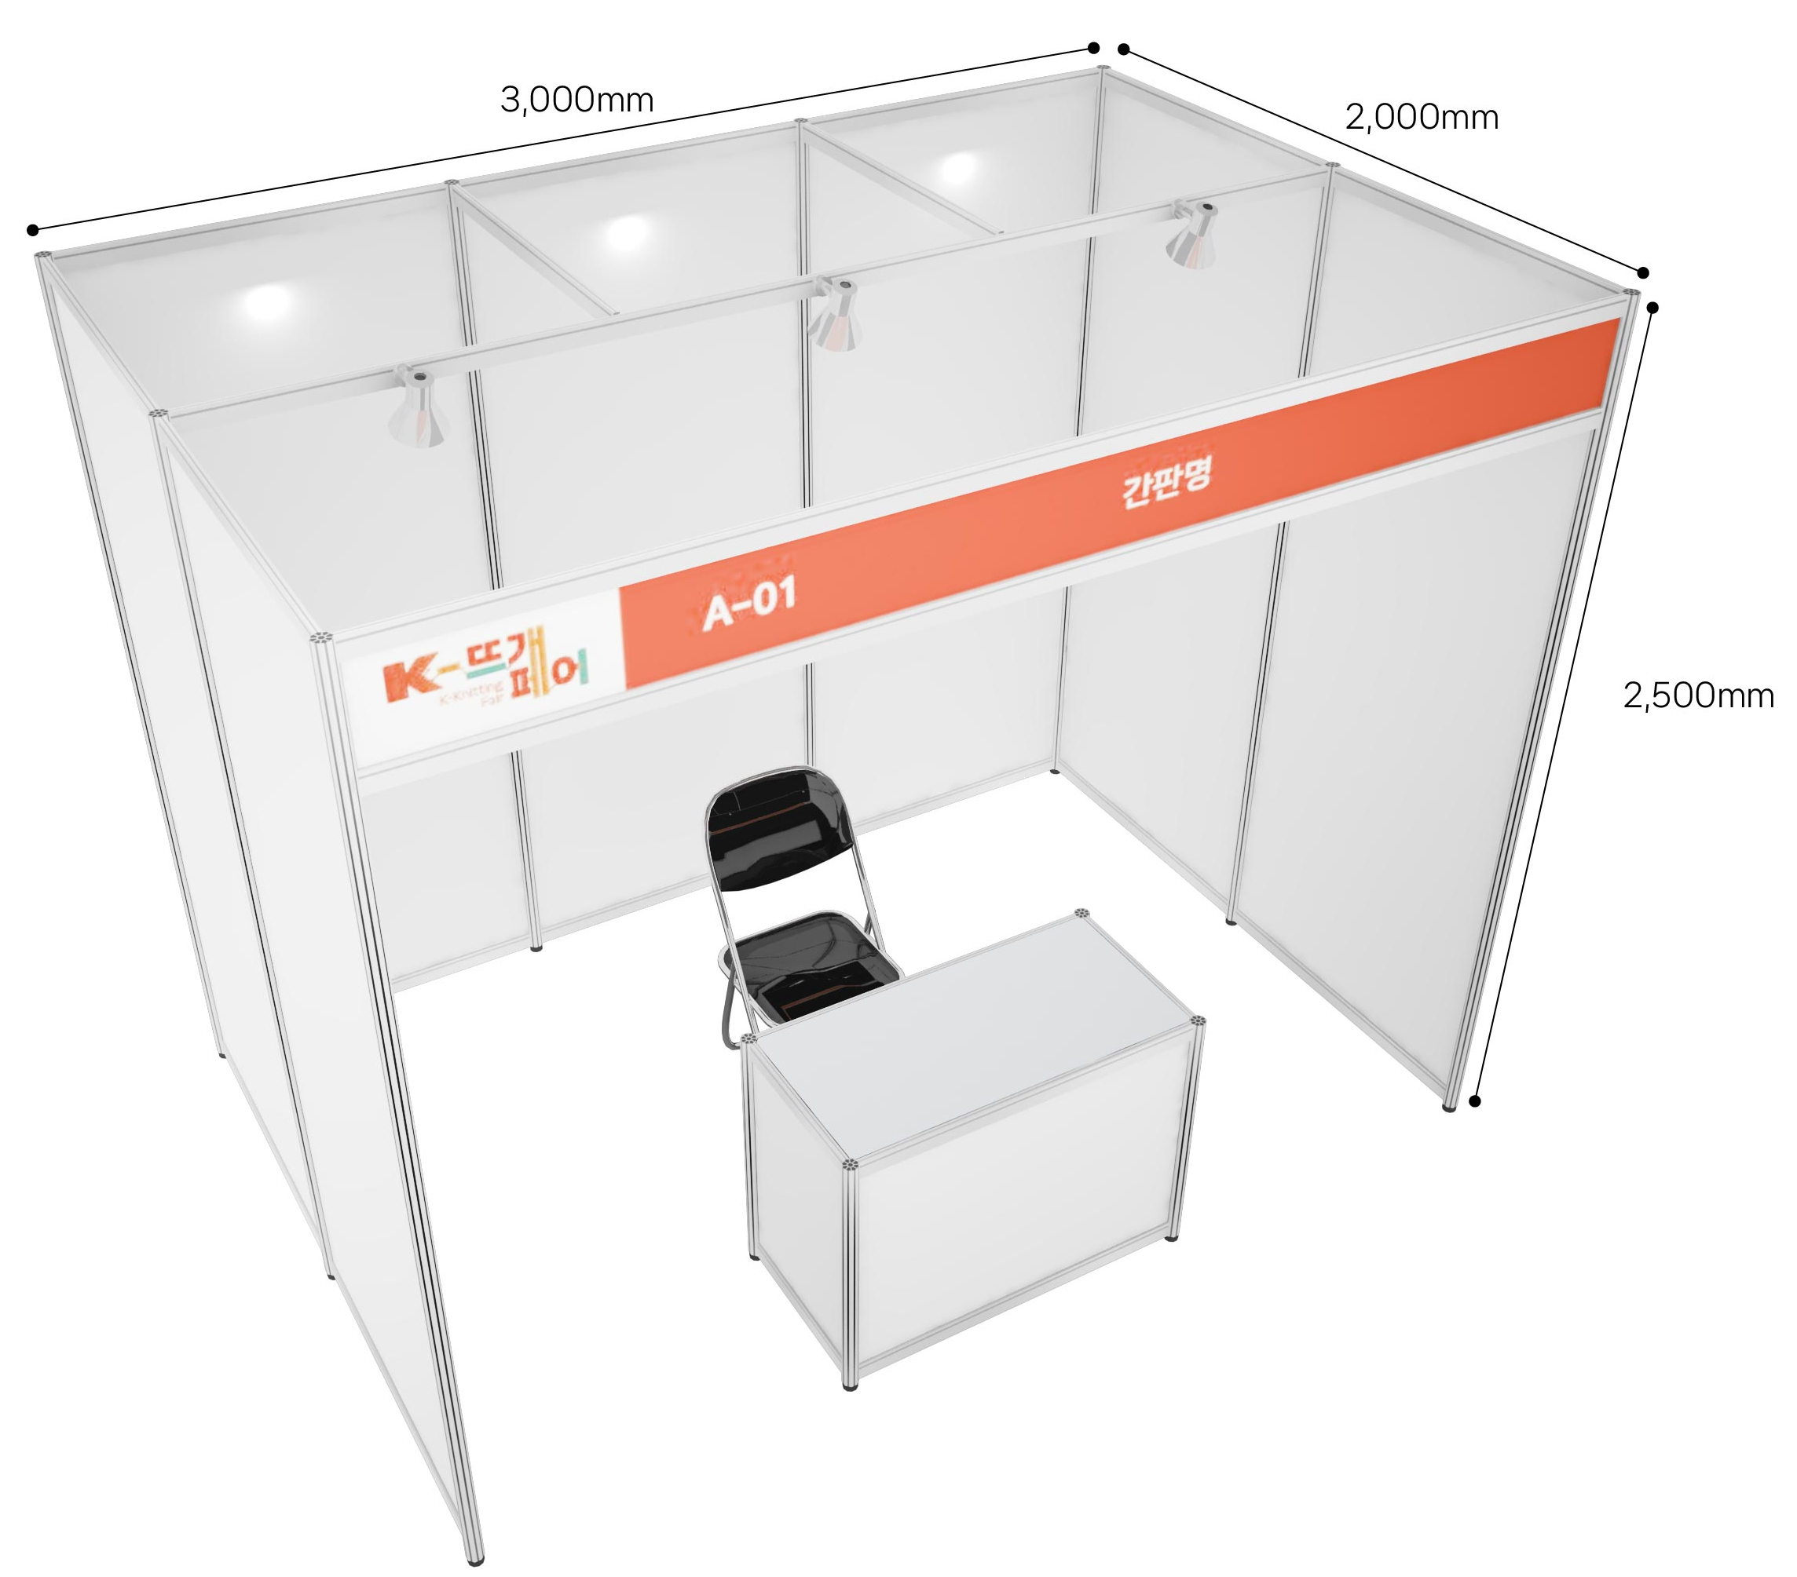 | 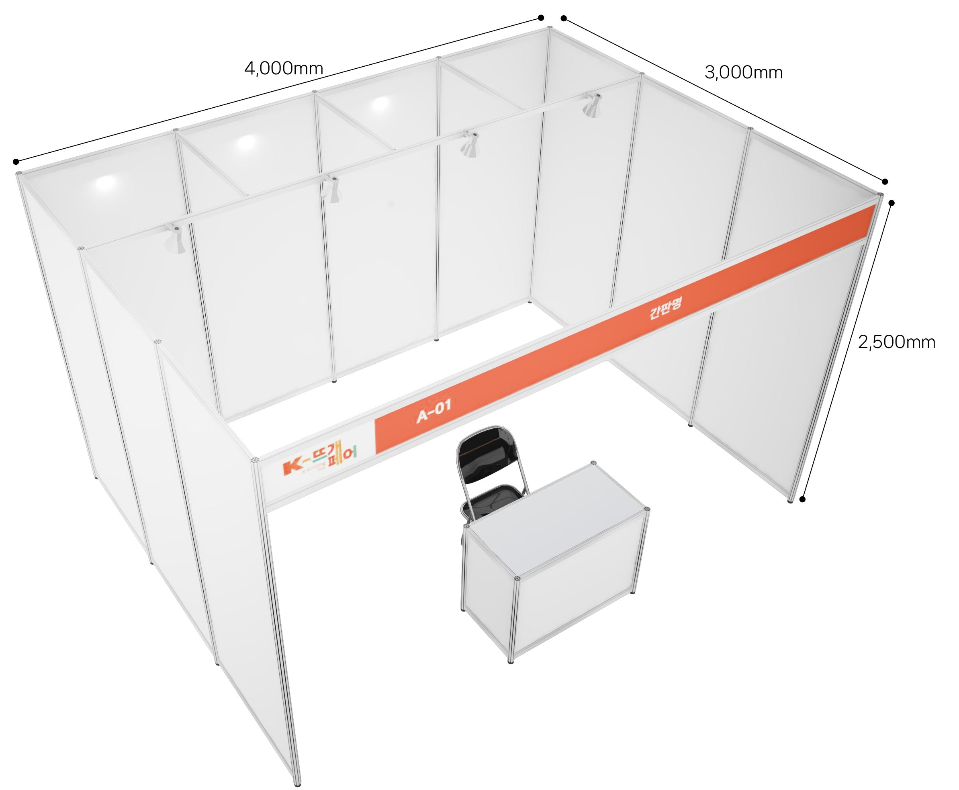
※ The images of each booth listed above are subject to change based on the organizer's circumstances.

3. Participation Fee in Total: USD___________________________________
I, hereby, confirm that I will follow the rules & regulations of ‘K-Knitting Fair 2027’ and that I have enclosed a payment (50% of the participation fee) and a copy of the payment remittance.

/ /
DD/MM/YY |  | Name of Applicant (Representative) |  | (Signature)

■ How to save your money when trying to rent a booth
• Early bird booking discount: 20% - discount (only for those participants who pay in a down payment after submitting the application form by June 11th, 2027)
• Discount for students: 10% (only for those participants who can submit a copy of their proof of enrollment)
• Previous Participants: 5% (who have participated this fair before)
※ Maximum discount rate : 30%

■ How to Apply; Tel: 82-2-761-2512 | Fax: 82-2-761-2517 | Email: info@knittingfair.com
Address: No. 1116, (Yeouido-dong), 33, Gukjegeumyung-ro 6-gil, Yeongdeungpo-gu, Seoul

The Rules & Regulations of K-Knitting Fair 2027

Article 1 Definition
1. "Exhibition" refers to ‘K-Knitting Fair 2027’.
2. "Organizer" refers to ‘CUNO’
3. "Exhibitor" refers to individual(artist), company, organization or group applied for the participation in this exhibition.

Article 2 Exhibition application and agreement
1. The one who wish to participate in the exhibition shall fill the application form, receive approval from the organizer and pay 50% of the total participation fee by bank transfer within 7 days.
2. After submitting the application form, if the organizer refuses to approve for harmonious constitution and operation of the exhibition, the agreement will not be effective.
3. Participation fee is;
Booth Type | Unit Price | Booth Type | Unit Price
Wooden A | USD 1,000 | Standard A | USD 900
Wooden B | USD 1,300 | Standard B | USD 1,300
Wooden C | USD 1,700 | Raw space  (Space Only) | USD 1,200
Workshop | USD 1,700 | Raw space  (Space Only) | USD 1,200
※ Corner booth fee is not included in the unit price. (USD 100)
4. Technical support and standard package construction will be provided by the organizer upon the request of the exhibitor. In case of any alternation in technical support request, the exhibitor shall inform the organizer in prompt manner. Any disadvantage occurred by the failure to notify is subject to the exhibitor’s responsibility.
5. The exhibitor shall display only the items specified in the application form, and if the signboards, business names, items, etc. differ from the details of the application on the day of the exhibition, the organizer may remove the relevant business from the site.
6. Method of Payment
· Bank: Shinhan Bank(신한은행)
· Account No.: 180-041-416640
· Beneficiary: Hyeyoung Choi
· Swift Code: SHBKKRSE

Article 3 Assignment of Exhibition Booth
1. Organizer has all rights to the booth assignment and Exhibitor may not object to the decision made. According to application and payment order, booth will be assigned considering country, item, size, exhibition results and other reasonable matters.
2. The organizer may change the allocated booth location in case the organizer acknowledges the necessity considering spacing harmony, viewing efficiency and exhibition effectiveness. Such change is under discretion of the organizer, and the exhibitor shall not object on the decision.

Article 4 Exhibition Management
1. Exhibitor shall display the items listed in the application and have someone to take care of the booth at all times.
2. If the Exhibitor displays items not listed in the application, displays items that do not fit the nature of the Exhibition, or conducts unapproved direct sales without prior permission from the Organizer, the Organizer may request the immediate suspension, withdrawal, or dismantling of the exhibit. In such cases, the participation fee will not be refunded, and the Exhibitor may not claim compensation.
3. Organizer may prohibit certain people from the exhibition, if necessary.
4. Exhibitor cannot use other area for the exhibit without prior approval from Organizer.
5. Exhibitor cannot use speaker or amplifier without prior approval Organizer and sales or loud activities are strictly prohibited.
6. For any damages that cannot be returned into original state, such as painting the floor/ceiling/wall, Exhibitor is liable for any reasonable compensation requested by Organizer regarding the restoration.

Article 5 Payment
1. Exhibitor shall make an initial payment of 50% of the total participation fee when submitting application and the balance shall be made before August 13 (Fri.), 2027. When submitting the application after August 13 (Fri.), 2027,100% of the participation fee shall be paid when submitting application.
2. In the event of Exhibitor not making the balance payment within the designated deadline, organizer may cancel the contract, and the Exhibitor cannot ask for refund. The matter will be resolved according to Article 6 of this Rules and Regulation.

Article 6 Termination of the Agreement (Exhibition Cancellation) and Penalty
1. The Exhibitor cannot assign the contract, sub-let or part with his site or stand or any portion of it without prior written consent from the Organizer. If the Exhibitor breaches this term, exhibition can be cancelled and the fee will not be subject to refund.
2. If the Exhibitor does not pay the participation fee within the designated period, 14days notice will be given to him/her to make the payment and still if the payment is not made, Organizer has the right to cancel the exhibition contract. In this case, Exhibitor is not entitled to refund.
3. In case the exhibitor cancels or refuses the whole or partial space, which is already registered due to own reason, the exhibitor shall inform the organizer in document and pay the penalty that is settled below within 14 days. Penalty is deducted from the paid participation fee, if not sufficient, the exhibitor shall pay the addition, and if surplus, the balance will be returned.
* Cancellation Penalty
- On or before 24th May 2027: 50% of participation fee
- From 25th May 2027 to 23rd June 2027: 60% of participation fee
- From 24th June 2027 to 23rd July 2027: 70% of participation fee
- From 24th July 2027 to 14th October 2027: 80% of participation fee
- On or after 15th October 2027: 100% of participation fee

Article 7 Cancellation of Exhibition or Alteration
In the event of cancellation or date change of the exhibition due to irresistible force or other causes not resulting from the Organizer, already paid exhibition fee will not be refunded and Exhibitor may not ask for compensation.

Article 8 Display of items
1. Exhibitor shall complete installment, entrance and display of the item within the designated date. In case of items not being displayed until 8 pm, Dec 16(Wed.), 2027, Organizer has the right to temporarily cancel that exhibition and ask for compensation.
2. Exhibitor can use their own space given by Organizer for the display of their items only from opening time to 8 p.m on designated date. If additional working hours are required, additional work application shall be submitted, and extra charge shall be made.

Article 9 Restoration
1. Exhibitor shall observe the opening and closing time, and all disadvantages arising from violation of this rule shall be the responsibility of the participant.
2. After the exhibition (October 24 (Sun.), 2027, from 6:00 PM onwards), Exhibitor shall restore booth space to the original state as fast as it possible. Exhibitor is liable for any expenses/losses, including additional charge caused by delay, arising to the Organizer from a delay of dismantling.

Article 10 Security and Safety
1. Organizer shall take proper action (aT Center’s exhibition regulation) to secure safety for the Exhibitor and visitors.
2. Exhibitor is fully liable for any damages or loss occurred during the exhibition preparation period, exhibition period and dismantling period.
3. If the Exhibitor intentionally or negligently causes fire, damage, loss, or other accidents resulting in harm to the Organizer or a third party, the Exhibitor shall be fully liable for all damages and must maintain appropriate insurance coverage for all materials and items.

Article 11 Fire Safety
1. All materials and items must be fire-resistant according to the safety regulations.
2. Organizer may ask for modification regarding fire prevention to the Exhibitor if necessary.

Article 12 Amendment
1. The Organizer reserves the right to modify at any time the provisions of the present Rules & Regulation; the Exhibitors shall comply with the modification.
2. The Exhibitors must comply with the regulations of aT Center.

Article 13 Disputes
In any disputes that may arise concerning interpretation of the present Rules & Regulations, the Exhibitor agrees to the competence of the Commercial Arbitration Rules of the Korean Commercial Arbitration Board and shall not bring a law-suit against the ruling.

